**DELHI TECHNOLOGICAL UNIVERSITY**



**PROJECT REPORT**

Prepared By:

RAO MAYANK (2K19/IT/107)

RITIK SHERAWAT (2K19/IT/110)

Submitted To:🡪

Mrs. Swati Sharda

**DELHI TECHNOLOGICAL UNIVERSITY**

(Formerly Delhi College of Engineering)

Bawana Road, Delhi, 110042

**CANDIDATES’S DECLARATION**

We, RAO MAYANK & RITIK SHERAWAT, Roll No(s). 2K19/IT/107 & 2K19/IT/110 repectively, students of B. Tech. in INFORMATION AND TECHNOLOGY, hereby declare that the project Dissertation titled ***TIME TABLE SCHEDULING*** which is submitted by us to the Department of Information and technology, Delhi Technological University, Delhi in partial fulfillment of the requirement for the award of the mid-semester component evaluation, semester-3 of Bachelor of Technology is original and not copied from any source without proper citation. This work has not previously formed a basis for the award of any degree, Diploma Associateship, Fellowship, or any similar title or recognition

Place: Delhi RAO MAYANK

Date: 1/12/2020 RITIK SHERAWAT

**DELHI TECHNOLOGICAL UNIVERSITY**

(Formerly Delhi College of Engineering)

Bawana Road, Delhi, 110042

**CERTIFICATE**

We hereby declare that the project Dissertation titled “TIME TABLE SCHEDULING” which is submitted by RAO MAYANK & RITIK SHERAWAT, Roll No(s). 2K19/IT/107 & 2K19/IT/110, Department of Information Technology, Delhi Technological University, Delhi in partial fulfillment of the requirement for the award of the mid-semester component evaluation, semester-3 of Bachelor of Technology, is the record of the project work carried out by the students under my supervision.

Place: Delhi Mrs. Swati Sharda

Date: 1/12/2020 Department of IT

Delhi Technological University

Bawana Road, Delhi,110042

**ACKNOWLEDGEMENT**

At the very outset of this report, we would like to extend our sincere and heartfelt obligation towards all the personages who have guided us with the project.

A special thanks to Mrs. Swati Sharda for teaching us the subject “Discrete Mathematics”. She helped us visualize the subject and to find its applications in real life. She supervised us with the intricacies of this project. She also offered many relevant and productive recommendations for the project, for which we are very grateful.

Finally, a thank you to all our family and friends who helped us with the project during such difficult times and gave worthy ideas.

**TIME TABLE SCHEDULING**

**AIM:**

*In this project we shall discuss Exam timetable scheduling problem. One of the most scheduling problems which can be precieved in any educational system is the time table generation. The presence of vast number of students and offered courses makes it difficult to schedule exam and time table in limited time. To solve this problem we are using graph coloring approach for generating exam time table.*

**PROBLEM STATEMENT:**

* *We have given the following information, with core subjects, elective subjects and supplementary papers.*
* *Fist semester subjects : Applied physics(AP), Mathematics(MA), Applied Chemistry(AC), Basic mechanical engineering(BME), FEC.*
* *Third semester subjects : OOPS, Data Structure(DS), Discrete mathematics(DST), Analog electronics(AE), AP, MA, AC. NOTE:- AP,MA,AC are the first semester subjects we are adding these subjects because we are assuming that some students got failed in these subjects and have to appear for supplementary exams and thus need to reappear.*
* *Fifth semester subjects : Theory of computation(TC), Computer networks(CN), Operating system(OS), MA, DST. NOTE:-MA,DST are first and third semester subjects respectively.*
* *We are assuming that some fifth semester students got failed in these and have supplementary papers for these subjects.*
* *This information is given to us .we have to make exam time table so that no student have two or more subject exam at same time.And also ask to give total time-slot for exam.*

SOLUTION:

* *For solving this problem, we make vertices of total number of subjects. And assign every vertex to one subject. Then we make edge between all subjects of every semester.*
* *Example :- MA is in all semesters so that MA vertex is connected to all other vertices of the graph.*
* *BME and FEC are only in first semester so that these both vertices connected to only first semester subject vertices.*
* *After doing this we get this type of graph like in figure.*

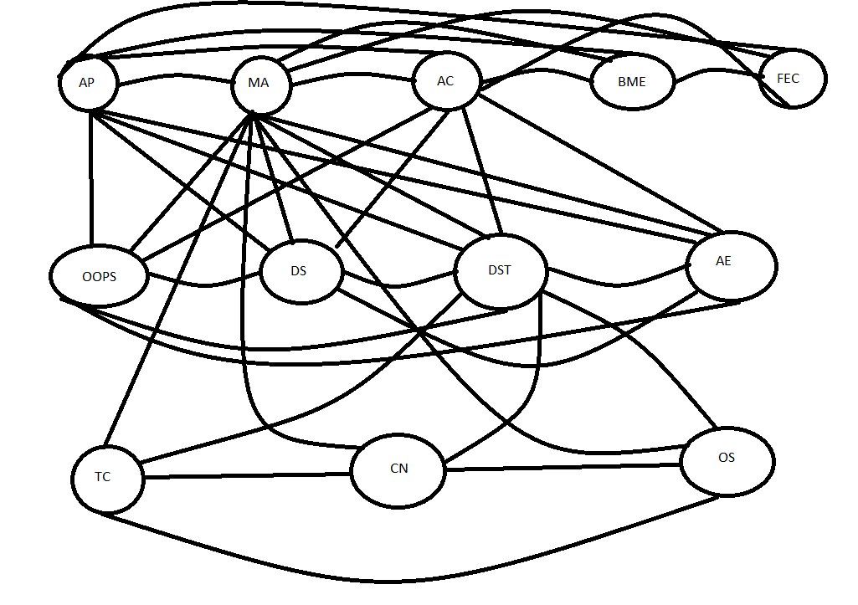

* *In this program we will assign color to the subjects based on adjacency list or matrix*
* *Two sources are said to be collided with each other if they are adjacent. we cannot assign same color to any two adjacent courses.*
* *We observe the first row we see that AP and MA cannot be assigned with same color since they are adjacent but AP and TC can be assigned same color as they are not adjacent.*
* *Like this we checked every row and got the following colored table*

ADJACENCY MATRIX AND LIST:

*LIST ->*

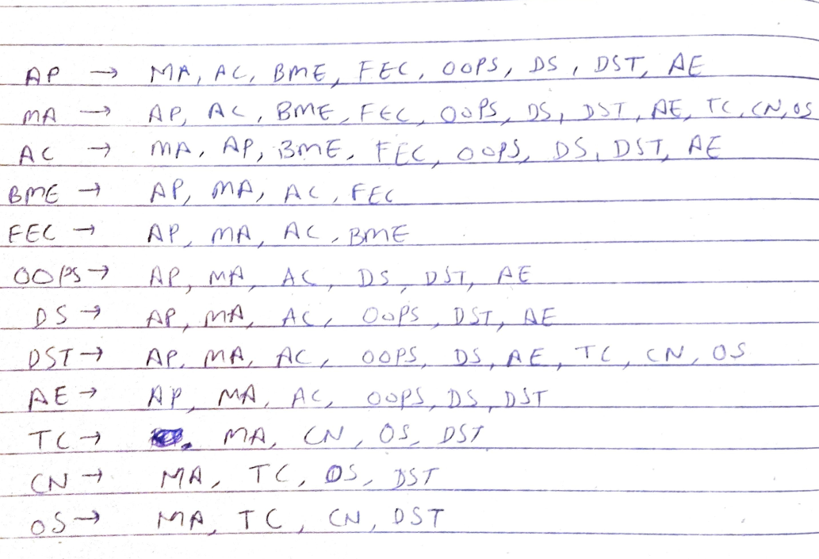

*MATRIX ->*

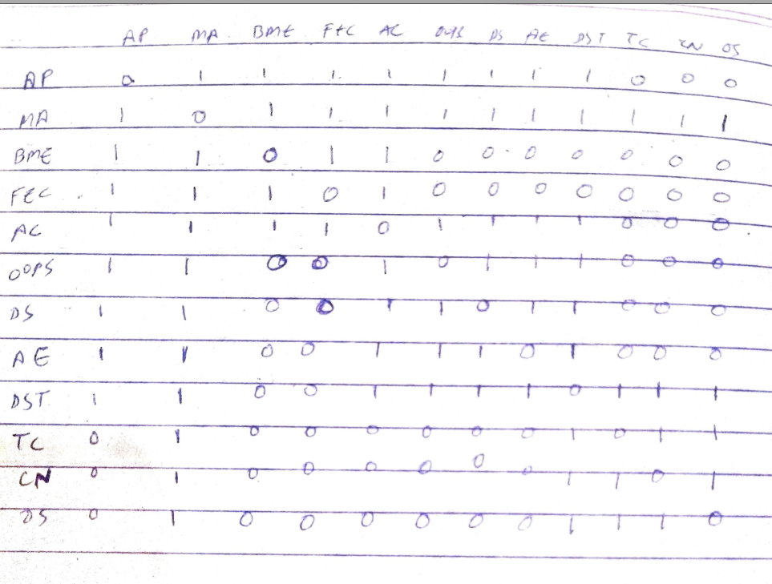

**COLOR DISTRIBUTION OF SUBJECTS:**

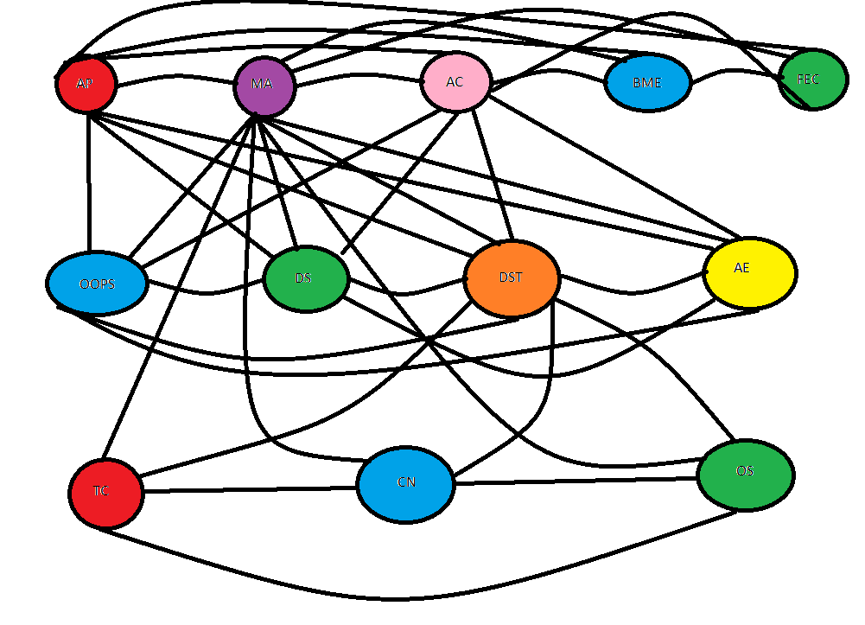

**EXAM TIME SLOTS:**

* *Using this graph we make seven group because there are seven different color. In every group there are same colored vertices.*
* *We need minimum 7 time slot to conduct exam. In first time slot we can conduct exam of AP and TC because they are in same group.*
* *In second time slot we take exam of MA*
* *In third time slot we take exam of OOPS,BME and CN.*
* *In fourth time slot we take exam of FEC,DS and OS.*
* *In fifth time slot we take exam of AC.*
* *In sixth time slot we take exam of AE.*
* *In final time slot we take exam of DST.*

ALGORITHM USED:

***Basic Greedy Coloring Algorithm***

*In the study of graph coloring problems in mathematics and computer science, a****greedy coloring****or****sequential coloring****is a coloring of the vertices of a graph formed by a greedy algorithm that considers the vertices of the graph in sequence and assigns each vertex its first available color. Greedy colorings can be found in linear time, but they do not in general use the minimum number of colors possible.*

CONCLUSION:

*By this project we made an exam time-table scheduling program where graph coloring methods were applied and a complete solution was provided.*